**First direct arena – Open Call**

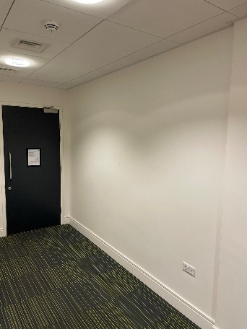**Space Specification**

**ROOM 1**

ARTWORK DIMENSIONS: 3.4m (width) x 2.6m (height)

WALL MATERIAL: Smooth plaster

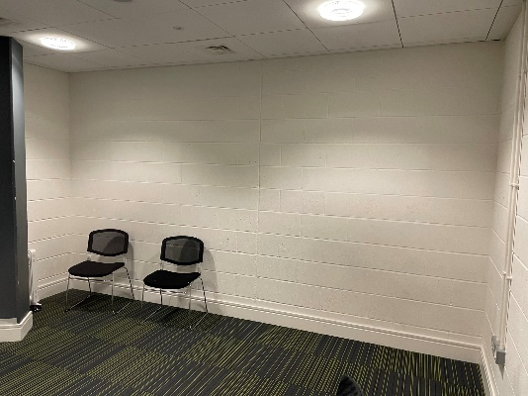

**ROOM 2**

ARTWORK DIMENSIONS: 4.5m (width) x 2.6m (height)

WALL MATERIAL: Painted brick

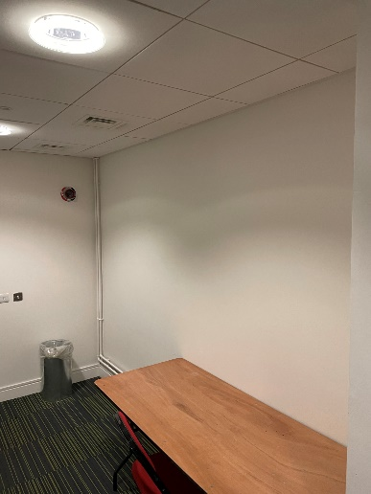**ROOM 3**

ARTWORK DIMENSIONS: 3.6m (width) x 2.6m (height)

WALL MATERIAL: Smooth plaster

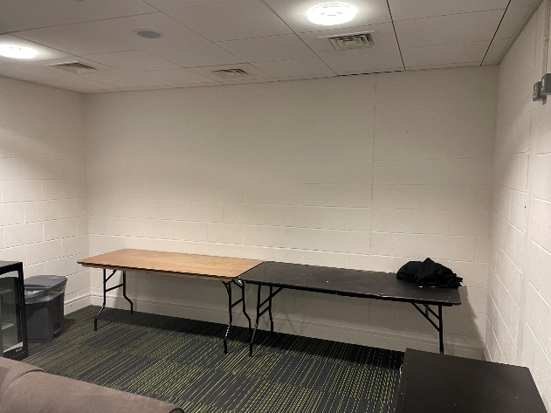

**ROOM 4**

ARTWORK DIMENSIONS: 4.5m (width) x 2.6m (height)

WALL MATERIAL: Painted brick

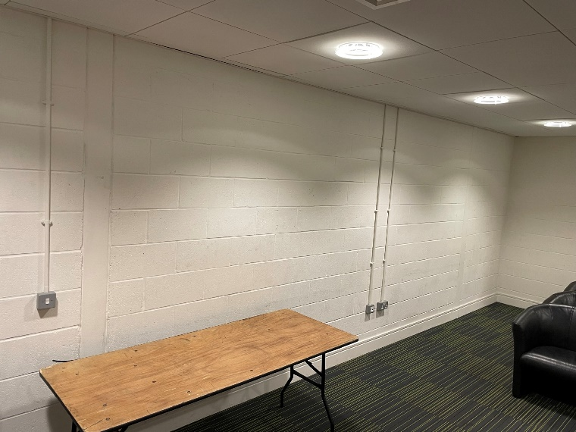**ROOM 5**

ARTWORK DIMENSIONS: 7.8m (width) x 2.6m (height)

WALL MATERIAL: Painted brick

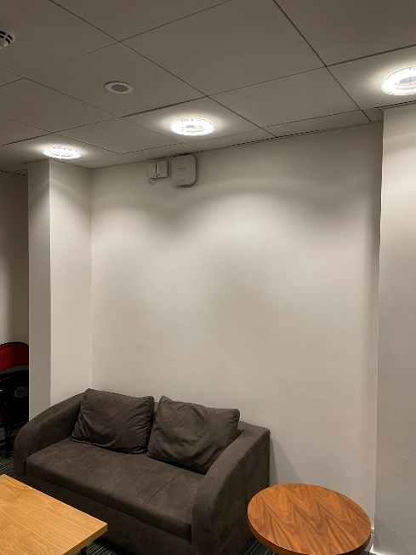

**ROOM 6**

ARTWORK DIMENSIONS: 2.5m (width) x 2.6m (height)

WALL MATERIAL: Smooth plaster

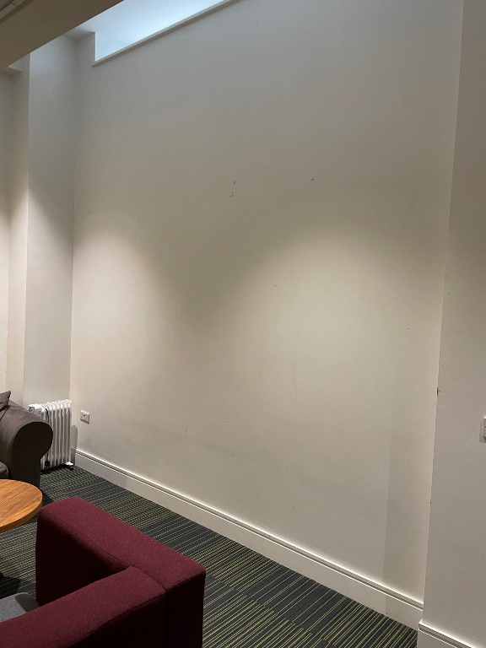

**ROOM 7**

ARTWORK DIMENSIONS: 3.5m (width) x 3.6m (height)

WALL MATERIAL: Smooth plaster

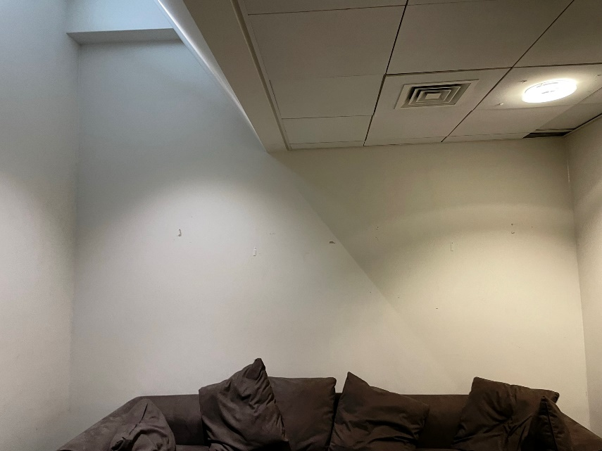**ROOM 8**

ARTWORK DIMENSIONS: 3.9m (width) x 2.6m (height) (with additional 1.3m above)

WALL MATERIAL: Smooth plaster

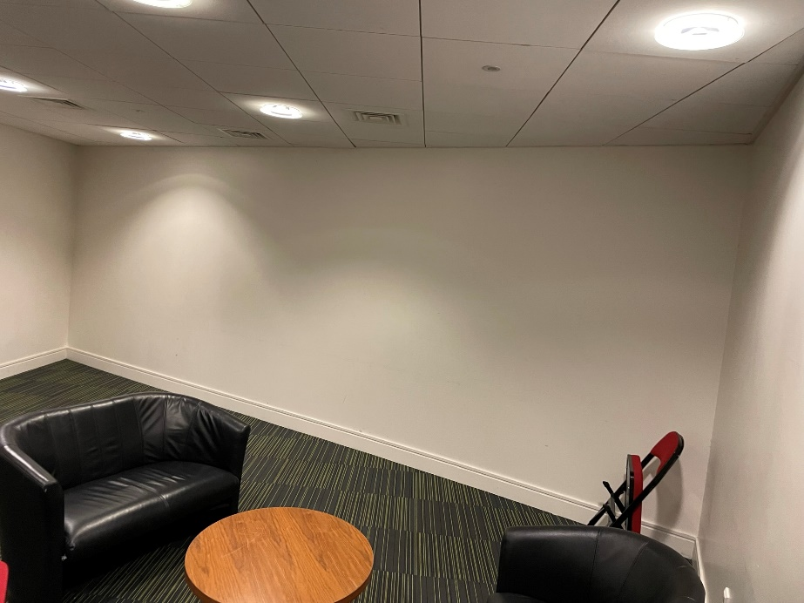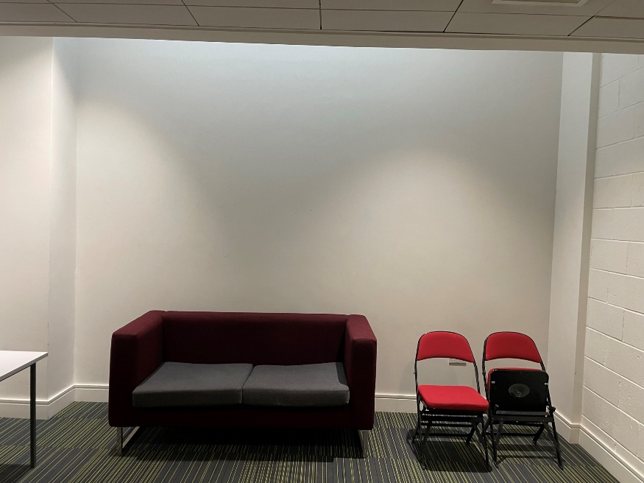

**ROOM 9**

ARTWORK DIMENSIONS: 4.1m (width) x 3.6m (height)

WALL MATERIAL: Smooth plaster

**ROOM 10**

ARTWORK DIMENSIONS: 6.9m (width) x 2.5m (height)

WALL MATERIAL: Smooth plaster